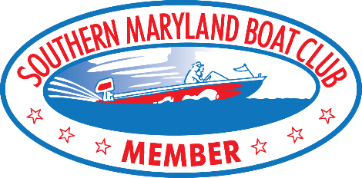

2023 SMBC MEMBERSHIP
FEE $40
(Annual Membership from January 1 to December 31)

Name___________________________________________ Age_________ D.O.B._________________

Address____________________________________________________________________________

City_________________________________________ State/Province__________________________

Country__________________________________________ Postal Code/Zip_____________________

Cell______________________________________Home Phone_______________________________

Email____________________________________________________________Shirt Size___________

PLEASE READ AND SIGN:
For myself and any member of my family, including all minors who accompany me or should otherwise participate in any activity of the Southern Maryland Boat Club, I hereby waive any claim for injury to my person, boat or equipment. I agree to hold the Southern Maryland Boat Club harmless and any and all other sponsors of the event, their employees, agents, volunteers, and assistants, for any injury or loss suffered by me, my family, or any invitee during or in connection with the 2023 membership year, whether such injury or loss resulted directly or indirectly from the negligent acts or omissions of said organization, sponsors, employees, volunteers, assistants, or others connected with the Southern Maryland Boat Club. I understand that in order to participate in any Southern Maryland Boat Club event, my boat must be adequately inspected and operated in a safe manner. I agree to take full responsibility for myself while in the boat either as a driver or rider. I will hold the Southern Maryland Boat Club blameless for any accident, injury or loss that might occur due to my participation in any event and free from all liability for accidents, injuries or losses.

________________________________________________________________ ________________________
SIGNATURE DATE

________________________________________________________________ ________________________ PARENT SIGNATURE (If member is under age 18) DATE

Mail completed form with check payable to:
SMBC, P. O. Box 203, Leonardtown, MD 20650

