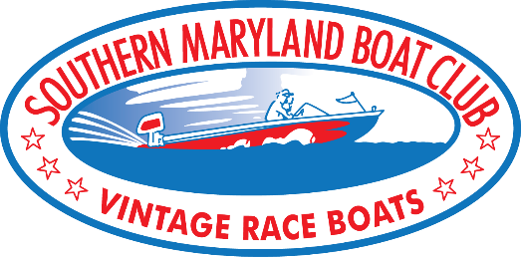
2023 Southern Maryland Boat Club
Commemorative Program Agreement
Piney Point “Rumble On The River” - June 10, 11, 2023
Leonardtown “Bash On The Bay” - July 29, 30, 2023

NAME__________________________________________________________________________________________

ADDRESS _______________________________________________________________________________________

CITY ___________________________________________________ STATE ____________ ZIP__________________

CELL PHONE ____________________________________ HOME PHONE ____________________________________

EMAIL __________________________________________________________________________________________

Please check your selection:

____ 3’ x 5’ Banner Color Display: $150

____ Full Page Color Ad: $150

____ Half Page Color Ad: $90

____ Quarter Page Color Ad: $60

Use the previous ad A new ad is being submitted

___________________________________________________________________ ___________________________
(Signature) (Date)

___________________________________________________________________
(Printed Name)

Southern Maryland Boat Club Contact ________________________________________________________________

Mail completed agreement with check payable to: - OR - Pay by PayPal:
SMBC www.PayPal.com to
P.O. Box 203 southernmarylandboatclub@yahoo.com
Leonardtown, MD 20650

Photo ready artwork can be submitted in original format (including business cards) or can be emailed to:
southernmarylandboatclub@yahoo.com

ALL ARTWORK and payment must be received by March 30, 2023, to allow for professional printing services.

